November 18, 15

Hao Ye has my permission to include the following paper, of which I was a co-author, in his doctoral dissertation.

Hao Ye, Richard J. Beamish, Sarah M. Glaser, Sue C. H. Grant, Chih-hao Hsieh, Laura J. Richards, Jon T. Schnute, and George Sugihara. “Equation-free mechanistic ecosystem forecasting using empirical dynamic modeling.” PNAS 112 (13): E1569-E1576 (2015).

Signed,

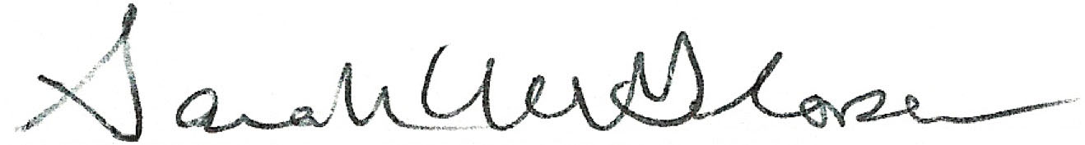

Sarah Glaser